Network In Network V1

0. Environment

|  |  |
| --- | --- |
| DataSet | CIFAR-10 |
| Language | Python3.5 & Tensorflow 1.0 |
| optimizer | Adam |
| Loss function | Cross entropy Loss |

Input : 32x32x3 size image

1. initialize

|  |  |
| --- | --- |
| layer | 3x3 conv (filter = 64, pad) |
| output | 32x32x64 |

2. module (10 times)

|  |  |
| --- | --- |
| Layer | 3x3 conv (filter = 64, pad) |
| output | 32x32x64 |
| Layer | 1x1 conv (filter = 64) |
| output | 32x32x64 |
| Layer | 1x1 conv (filter = 64) |
| output | 32x32x64 |
| Layer | 1x1 conv (filter = 64) |
| output | 32x32x64 |

3.Average_pool

|  |  |
| --- | --- |
| layer | 1x1 conv (filter = 10) |
| output | 32x32x10 |
| layer | 32x32 average_pool |
| output | 10 |

4. Overall

|  |  |
| --- | --- |
| Training(7600 iteration) | Time : 23125.742181777954 seconds |
| Accuracy : 0.33 |
| Validation | Accuracy : 0.324 |
| Re-training(64 iteration) | Accuracy : 0.304 |
| Re-Validation | Accuracy : 0.324 |
| Test | Acurracy : 0.31 |

Training

Iteration 0: with minibatch training loss = 11.4 and accuracy of 0.094

Iteration 100: with minibatch training loss = 2.11 and accuracy of 0.25

Iteration 200: with minibatch training loss = 1.98 and accuracy of 0.33

Iteration 300: with minibatch training loss = 1.81 and accuracy of 0.31

Iteration 400: with minibatch training loss = 1.95 and accuracy of 0.33

Iteration 500: with minibatch training loss = 1.86 and accuracy of 0.3

Iteration 600: with minibatch training loss = 1.98 and accuracy of 0.27

Iteration 700: with minibatch training loss = 2.07 and accuracy of 0.38

Epoch 1, Overall loss = 4.07 and accuracy of 0.257

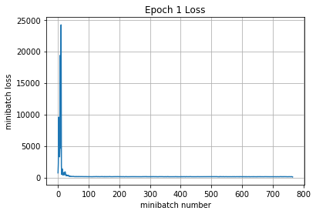

Iteration 800: with minibatch training loss = 2.04 and accuracy of 0.28

Iteration 900: with minibatch training loss = 1.83 and accuracy of 0.38

Iteration 1000: with minibatch training loss = 2.14 and accuracy of 0.22

Iteration 1100: with minibatch training loss = 1.89 and accuracy of 0.34

Iteration 1200: with minibatch training loss = 1.98 and accuracy of 0.34

Iteration 1300: with minibatch training loss = 1.87 and accuracy of 0.31

Iteration 1400: with minibatch training loss = 1.8 and accuracy of 0.34

Iteration 1500: with minibatch training loss = 1.88 and accuracy of 0.31

Epoch 2, Overall loss = 1.92 and accuracy of 0.318

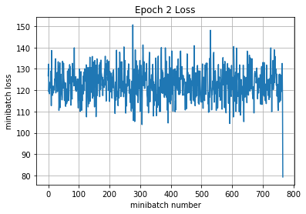

Iteration 1600: with minibatch training loss = 1.88 and accuracy of 0.42

Iteration 1700: with minibatch training loss = 1.87 and accuracy of 0.34

Iteration 1800: with minibatch training loss = 1.8 and accuracy of 0.33

Iteration 1900: with minibatch training loss = 2.09 and accuracy of 0.36

Iteration 2000: with minibatch training loss = 1.84 and accuracy of 0.38

Iteration 2100: with minibatch training loss = 1.94 and accuracy of 0.31

Iteration 2200: with minibatch training loss = 1.82 and accuracy of 0.38

Epoch 3, Overall loss = 1.89 and accuracy of 0.332

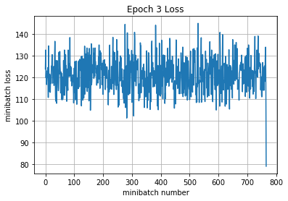

Iteration 2300: with minibatch training loss = 1.85 and accuracy of 0.34

Iteration 2400: with minibatch training loss = 1.98 and accuracy of 0.25

Iteration 2500: with minibatch training loss = 1.97 and accuracy of 0.34

Iteration 2600: with minibatch training loss = 2.03 and accuracy of 0.31

Iteration 2700: with minibatch training loss = 1.8 and accuracy of 0.38

Iteration 2800: with minibatch training loss = 1.94 and accuracy of 0.34

Iteration 2900: with minibatch training loss = 1.89 and accuracy of 0.39

Iteration 3000: with minibatch training loss = 1.88 and accuracy of 0.28

Epoch 4, Overall loss = 1.88 and accuracy of 0.336

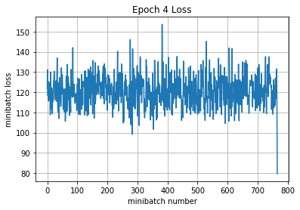

Iteration 3100: with minibatch training loss = 1.7 and accuracy of 0.45

Iteration 3200: with minibatch training loss = 2.02 and accuracy of 0.34

Iteration 3300: with minibatch training loss = 2.02 and accuracy of 0.31

Iteration 3400: with minibatch training loss = 1.8 and accuracy of 0.34

Iteration 3500: with minibatch training loss = 2.02 and accuracy of 0.2

Iteration 3600: with minibatch training loss = 1.83 and accuracy of 0.38

Iteration 3700: with minibatch training loss = 2.09 and accuracy of 0.22

Iteration 3800: with minibatch training loss = 2.03 and accuracy of 0.25

Epoch 5, Overall loss = 1.88 and accuracy of 0.338

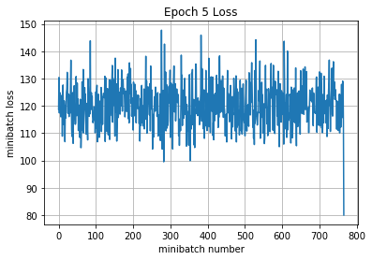

Iteration 3900: with minibatch training loss = 1.99 and accuracy of 0.22

Iteration 4000: with minibatch training loss = 2.03 and accuracy of 0.33

Iteration 4100: with minibatch training loss = 1.84 and accuracy of 0.38

Iteration 4200: with minibatch training loss = 1.81 and accuracy of 0.33

Iteration 4300: with minibatch training loss = 2.03 and accuracy of 0.33

Iteration 4400: with minibatch training loss = 2.16 and accuracy of 0.33

Iteration 4500: with minibatch training loss = 1.87 and accuracy of 0.36

Epoch 6, Overall loss = 1.88 and accuracy of 0.339

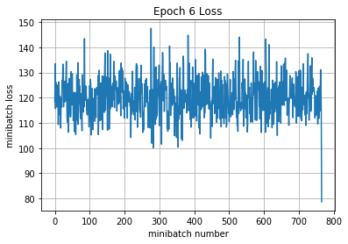

Iteration 4600: with minibatch training loss = 1.9 and accuracy of 0.36

Iteration 4700: with minibatch training loss = 1.66 and accuracy of 0.38

Iteration 4800: with minibatch training loss = 1.86 and accuracy of 0.33

Iteration 4900: with minibatch training loss = 1.96 and accuracy of 0.33

Iteration 5000: with minibatch training loss = 1.84 and accuracy of 0.34

Iteration 5100: with minibatch training loss = 1.81 and accuracy of 0.34

Iteration 5200: with minibatch training loss = 1.65 and accuracy of 0.3

Iteration 5300: with minibatch training loss = 2.03 and accuracy of 0.28

Epoch 7, Overall loss = 1.88 and accuracy of 0.338

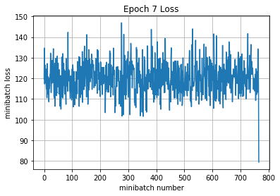

Iteration 5400: with minibatch training loss = 1.97 and accuracy of 0.3

Iteration 5500: with minibatch training loss = 1.92 and accuracy of 0.34

Iteration 5600: with minibatch training loss = 1.89 and accuracy of 0.36

Iteration 5700: with minibatch training loss = 2.02 and accuracy of 0.38

Iteration 5800: with minibatch training loss = 1.86 and accuracy of 0.3

Iteration 5900: with minibatch training loss = 1.91 and accuracy of 0.3

Iteration 6000: with minibatch training loss = 1.66 and accuracy of 0.34

Iteration 6100: with minibatch training loss = 1.89 and accuracy of 0.27

Epoch 8, Overall loss = 1.88 and accuracy of 0.337

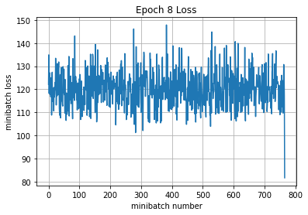

Iteration 6200: with minibatch training loss = 1.95 and accuracy of 0.34

Iteration 6300: with minibatch training loss = 2.03 and accuracy of 0.38

Iteration 6400: with minibatch training loss = 1.92 and accuracy of 0.3

Iteration 6500: with minibatch training loss = 1.84 and accuracy of 0.44

Iteration 6600: with minibatch training loss = 1.8 and accuracy of 0.45

Iteration 6700: with minibatch training loss = 1.91 and accuracy of 0.27

Iteration 6800: with minibatch training loss = 1.8 and accuracy of 0.36

Epoch 9, Overall loss = 1.88 and accuracy of 0.335

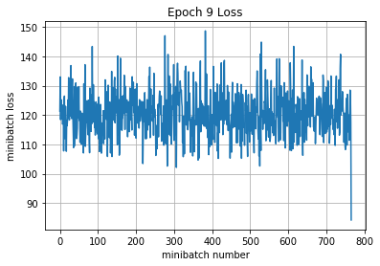

Iteration 6900: with minibatch training loss = 1.89 and accuracy of 0.31

Iteration 7000: with minibatch training loss = 1.78 and accuracy of 0.42

Iteration 7100: with minibatch training loss = 1.93 and accuracy of 0.36

Iteration 7200: with minibatch training loss = 1.57 and accuracy of 0.5

Iteration 7300: with minibatch training loss = 2.01 and accuracy of 0.33

Iteration 7400: with minibatch training loss = 1.86 and accuracy of 0.3

Iteration 7500: with minibatch training loss = 2.02 and accuracy of 0.36

Iteration 7600: with minibatch training loss = 1.8 and accuracy of 0.33

Epoch 10, Overall loss = 1.89 and accuracy of 0.33

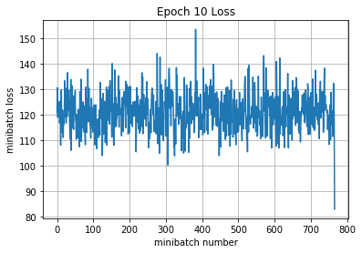

23125.742181777954

Validation

Epoch 1, Overall loss = 1.96 and accuracy of 0.324

Training

Epoch 1, Overall loss = 1.95 and accuracy of 0.304

Validation

Epoch 1, Overall loss = 1.96 and accuracy of 0.324

Test

Epoch 1, Overall loss = 1.95 and accuracy of 0.31